GitHub Migration Summary Report

cagrid-docs

Inventrio LLC

December 2012 - September 2013

John Eisenschmidt
<john.eisenschmidt@inventrio.com>

May 28, 2013

- Personnel Who Worked on Migration
List all the team members who worked on the migration effort.

Name | Title/Role | Contact Information
Will Ryan | Developer | <will.ryan@inventrio.com>
Justin Kuss | Developer | <justin.kuss@inventrio.com>
John Eisenschmidt | Project Manager | <john.eisenschmidt@inventrio.com>
Scott Oster | Architect | <scott.oster@inventrio.com>
Steve Langella | Architect | <steve@inventrio.com>
Shannon Hastings | Architect | <shannon.hastings@inventrio.com>
Insert additional rows as needed.

- Migration Overview

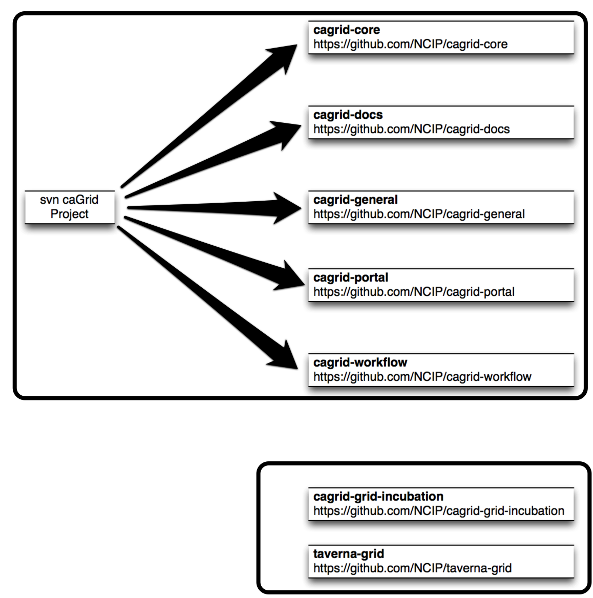
- Description of Work Completed
List all the activities that were performed to complete the migration (preferably in the order they were performed). Account for any automated tools that were created and/or used in support of this process.

ID | Activity | Description | Time Spent
 | https://github.com/NCIP/ncip.github.com/wiki/How-to-Migrate-from-Subversion
 | https://github.com/NCIP/ncip.github.com/wiki/Splitting-a-repository
Insert additional rows as needed.

SVN repository before conversion
Includes trunk only
Path | Size | Files | Conversion Time | URL
/Software | 1.8G | 14271 | NA | https://ncisvn.nci.nih.gov/svn/cagrid/trunk/cagrid/Software
/Software/workflow | 12M | 339 | NA
/Software/general | 242M | 1791 | NA
/Software/core | 1.1G | 6622 | NA
/Software/portal | 487M | 5279 | NA
Git repository after conversion
Includes trunk only. Includes Git files.
Path | Size | Files | Conversion Time | URL
/Software | 3.2G | 14393 | 0:01:12:50
/Software/workflow | 28M | 428 | 0:00:01:53 | https://ncisvn.nci.nih.gov/svn/cagrid/trunk/cagrid/Software/workflow
/Software/general | 396M | 2000 | 0:00:05:52 | https://ncisvn.nci.nih.gov/svn/cagrid/trunk/cagrid/Software/general
/Software/core | 2.0G | 6654 | 0:00:49:13 | https://ncisvn.nci.nih.gov/svn/cagrid/trunk/cagrid/Software/core
/Software/portal | 769M | 5311 | 0:00:15:52 | https://ncisvn.nci.nih.gov/svn/cagrid/trunk/cagrid/Software/portal

- Migration Artifacts
List all the artifacts of the product with appropriate locations.

ID | Artifact | Location(s)
1 | Source code | https://github.com/NCIP/cagrid-docs
2 | Documentation (including repository-based, wiki, other) | https://github.com/NCIP/ncip.github.com/wiki/Splitting-a-repository  http://www.cagrid.org
3 | Data (test data and seed data)
4 | Issue Tracker | https://tracker.nci.nih.gov/browse/CAGRID
5 | Binaries and installation packages (If there are any binaries and installation packages, please include these links in README.txt) | http://gforge.nci.nih.gov/frs/?group_id=25
6 | Release notes | http://gforge.nci.nih.gov/frs/shownotes.php?release_id=4219
7 | Production / Development /QA URLs if deployed at NCI | Production EPRs are listed here: https://cabig.nci.nih.gov/community/workspaces/Architecture/caGrid/
8 | Other useful links, if any
Insert additional rows as needed

- Issues
List all the issues that were encountered during the migration and the steps taken to resolve them.

ID | Issue | Status | Resolution/Proposed Resolution
 | Github performance when pushing code | Resolved
Insert additional rows as needed.

- Success factors
List or describe what went right during the entire migration process.

ID | Success factor
 | Support from NCIP github migration team
Insert additional rows as needed.

7. Lessons learned / Future Improvements
List the lessons learned during the migration process including things that you would do differently if you have to do migration of other tool and suggestions to other teams

ID | Lessons Learned/Enhancements/Improvements
Insert additional rows as needed.

8. Verification (Please refer to https://github.com/NCIP/ncip.github.com/wiki/Migration-Checklists#wiki-quality-assurance for more details)

ID | Verification Check | Result
1 | Check if a 1-2 line description is added to the repository | Verified
2 | Check that the repo clones correctly and leaves "master" checked out.  $ git clone https://github.com/NCIP/<PROJECTNAME>.git  $ cd <PROJECTNAME>  $ git status | Verified
3 | Check that the LICENSE, NOTICE, and README files appear in the master branch | Verified
4 | Check that the LICENSE.txt file also appears in the gh-pages branch | Verified
5 | Check that the LICENSE, NOTICE, and README template placeholders have been replaced | Verified
6 | Check that all links in the README file work | Verified
7 | Check that the text in LICENSE, NOTICE, and README files matches the text provided in the appropriate templates at https://github.com/NCIP/ncip.github.com/wiki/Templates | Verified
8 | Check files of several source code types to ensure the appropriate copyright header is placed and template placeholders have been replaced | Verified
9 | Check that the URL to the LICENSE.txt file works | Verified
10 | Check that the URL to the LICENSE.txt file is of the form:  http://ncip.github.com/<PROJECTNAME>/LICENSE.txt | Verified
11 | Do a web search for the tool and check that the appropriate links are found for  - User Documentation  - Reference Web Sites  - Wiki Documentation  - GitHub repository  Knowledge Center | Verified
12 | Check that Subversion revision numbers are mentioned in the commit messages for future reference. Run:  $ git log  and look for commit message lines containing the corresponding Subversion revision numbers. For example:  SVN-Revision: 1234 | Verified
13 | Check that a README file appears in the corresponding docs and data directories. | Verified
14 | Check that the format of README file in the corresponding docs repository match the template at  https://github.com/NCIP/ncip.github.com/wiki/Templates#wiki-readme-for-documents and the template tokens are replaced. | Verified
15 | Check that the format of README file in the corresponding data repository matches the template at  https://github.com/NCIP/ncip.github.com/wiki/Templates#wiki-readme-for-data and the tokens are replaced. | Verified
16 | Check that format of CONTRIBUTING.rst file in the main repository matches the template at https://github.com/NCIP/ncip.github.com/wiki/Templates#wiki-contributing | Verified
17 | Inform the PO to create a helpdesk ticket to remove write access to all the user of the repository. | Verified
Insert additional rows as needed.

